**Aim:** Data Visualization and beautifying the charts and plots using ggplot

**IDE:** R Studio

**Theory:**

**ggplot2 package in R Programming Language** also termed as **Grammar of Graphics** is a free, open-source, and easy-to-use visualization package widely used in [R](https://www.geeksforgeeks.org/introduction-to-r-programming-language/). It is the most powerful visualization package written by Hadley Wickham.

It includes several layers on which it is governed. The layers are as follows:

## Building Blocks of layers with the grammar of graphics

* **Data:** The element is the data set itself
* **Aesthetics:** The data is to map onto the Aesthetics attributes such as x-axis, y-axis, color, fill, size, labels, alpha, shape, line width, line type
* **Geometrics:** How our data being displayed using point, line, histogram, bar, boxplot
* **Facets:** It displays the subset of the data using Columns and rows
* **Statistics:** Binning, smoothing, descriptive, intermediate
* **Coordinates:** the space between data and display using Cartesian, fixed, polar, limits
* **Themes:** Non-data link

**Program:**

Write the program (R script) that beautifies the charts and plots using ggplot for the given visuals:

1. Bar Chart
2. Histogram
3. Pie Chart
4. Scatter Plot

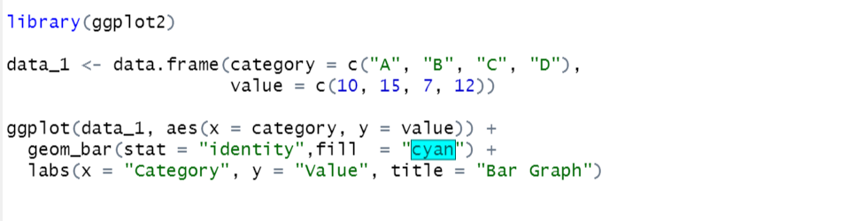

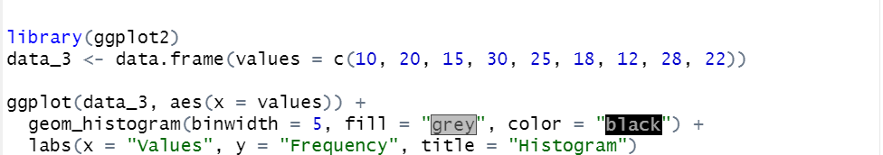

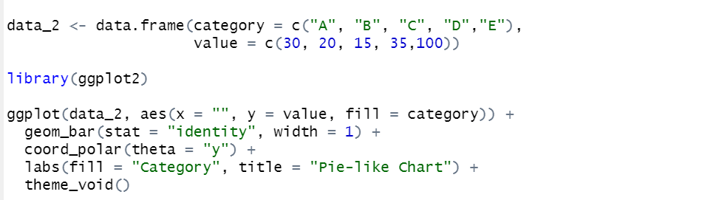

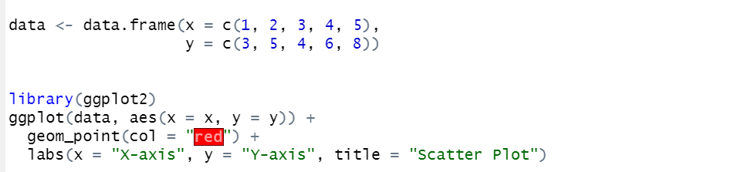

**Output:**

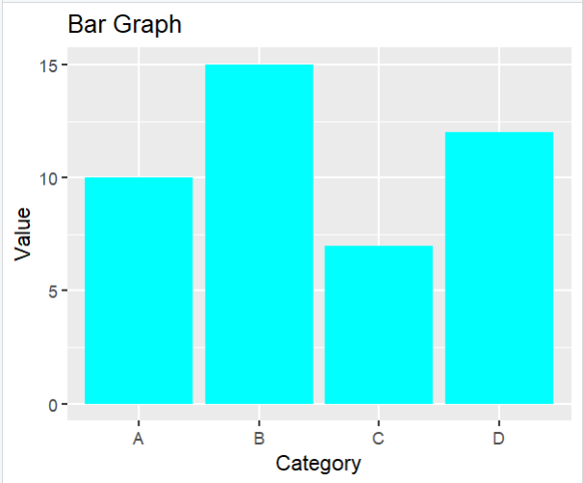

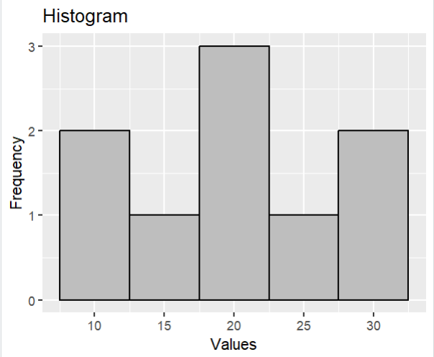

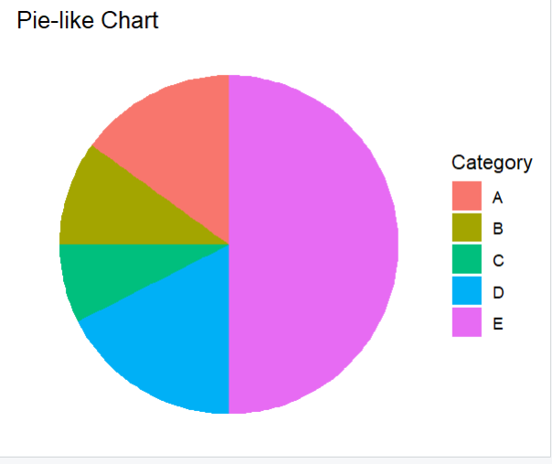

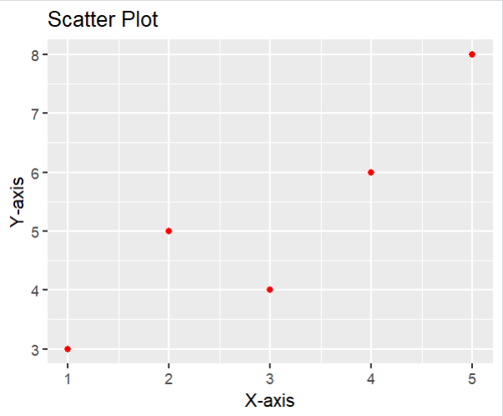

**Observation and Learnings:-**

**__________________________________________________________________________________________________________________________________________________________________________________________________________________________________________________________________________________________________________________________.**